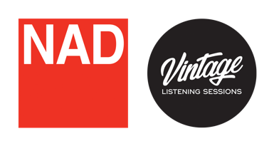

NAD Announces Vintage Listening Sessions
  - A series of global retail events inviting fans to experience the
rich history of hi-fi with vintage product showcases and demos.
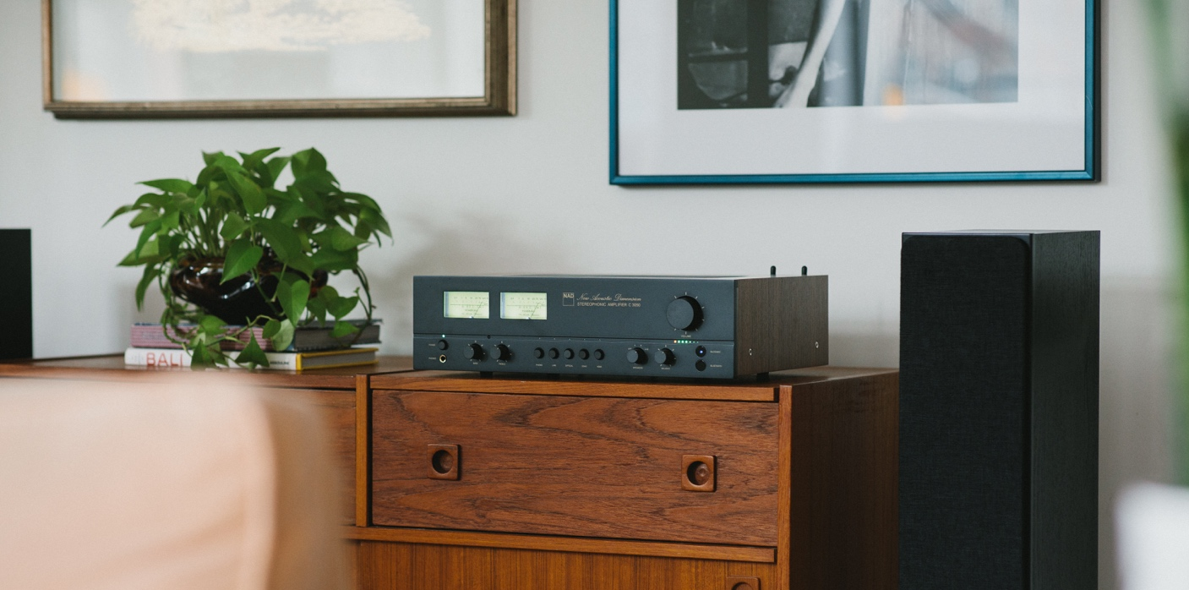
NAD Vintage Listening Sessions will include listening demos of the C 3050 Stereophonic Amplifier.

Toronto, Canada, September 25, 2023 – NAD Electronics, a leading manufacturer of premium audio and video products, is excited to announce NAD Vintage Listening Sessions, a series of global retail events connecting fans with the brand’s storied legacy and deep rooted history in hi-fi. These special in-store events provide a deep look at NAD’s history with a branded activation featuring vintage products, expertly curated playlists, and demos of the C 3050 Stereophonic Amplifier. The Vintage Listening Sessions will take place September 2023 to February 2024 at participating NAD retailers.

EXPERIENCE 50 YEARS OF AUDIO LEGACY AND INNOVATION
These special events will embrace the last five decades of acoustic design and innovation with a display of iconic NAD products and other exclusive promotional activities. The new C 3050 Stereophonic Amplifier will be available for private in-store demos, in addition to demos of the original NAD 3030 at select locations.

The C 3050 Stereophonic Amplifier combines NAD’s iconic sound with a retro design inspired by the classic NAD 3030. It employs advanced audio processing and the latest generation of HybridDigital™ amplification to deliver 100 watts per channel of FDP-rated power with stunning clarity and virtually unmeasurable distortion. The NAD C 3050 is also constructed with NAD’s patented MDC 2 technology and can be upgraded to include features such as BluOS®, Apple AirPlay 2, and Dirac Live Room Correction

CURATED VINTAGE PLAYLISTS BY INDUSTRY ICONS
Each Vintage Listening Sessions event will feature specially curated playlists that transport them back to the 1970s, and the debut of the original NAD 3030. Playlists will be handcrafted by notable industry figures, including British producer EG White, emerging UK recording artist Benny Atlas, and NAD Product Manager, Cas Oostvogel. Select events to include other special guests and curators.
Visit nadelectronics,com/vintagesessions for more information and events near you.

About NAD Electronics
Founded in 1972 and now sold in over 80 countries, NAD Electronics is renowned for its
award-winning line of high-quality components for audio, home theatre and custom
installation applications. Since the beginning, NAD’s commitment to four core values –
innovation, innovation, simplicity, performance, and value – have earned it a cult-like
following that catapulted it to becoming a household name amongst audiophiles and
music lovers alike. To this day, the brand continues to design and manufacture some of
the most acclaimed and affordable hi-fi components that include modern features and
technologies meant to appeal to a new generation of audiophiles.

contacts

Corporate Contact
June Ip
Marketing
media@nadelectronics.com

US Media Relations
Jeff Touzeau (OLEX Communications – US/Canada)
+1 914-602-2913
jeff@olexcommunications.us

UK Media Relations
Steve Dalton (OLEX Communications – UK)
+44 (0) 7748-117-864
steve@olexcommunications.co.uk

Links
Website: https://nadelectronics.com
Images: https://brandlibrary.lenbrook.com/portals/nadelectronics
Facebook: https://www.facebook.com/nadelectronics
Twitter: https://twitter.com/NADElectronics
Instagram: https://www.instagram.com/nadelectronics/

# # #

